**Creative Brief**

Description of the Project

I have decided to create my comic strip based on stills from the hugely successful 1977 film Star Wars Episode IV: A New Hope. Written and Directed by George Lucas it is the first film released in the saga and the fourth chronologically.

Star Wars is one of the highest grossing film franchises of all time. It is set in a distant galaxy in the distant past and tells the story of the epic battle between the Jedi and the Sith. It is referenced in many films and television programmes and has spawned many spoof versions such as Spaceballs and Family Guy: Blue Harvest. Lucasfilm also produced its own animated television series and animated feature film as well as a collection of video games. There are also a large amount of books published about the Star Wars universe. There are six films currently in the franchise with a seventh set for production by Disney.

I have chosen to do my comic on the scene from Episode IV: A New Hope where Darth Vader battles Obi Wan Kenobi and ultimately defeats him. This is an important point in the films plot as Kenobi’s last line to Darth Vader before being reduced to a pile of robes is “If you strike me down then I will become more powerful than you can possibly imagine.” Luke Skywalker witnesses the death of his mentor only to realise the importance of Obi Wans sacrifice later in the film.

The comic will be accompanied by a website that describes its creative design and hosts the comic in a complimentary environment.

Target Audience

The target audience of the site is anybody who is a fan of the Star Wars saga. This is a huge audience because of the amount of video games and literature published on the subject. This will also include a large age range as the first film was released in 1977 and the latest instalment in 2005.

It should also appeal to anybody who has seen the any of the many films and television series that have referenced the Star Wars universe.

Tone of the Site

The site will attempt to match the general tone of the Star Wars saga.

At the point in the storyline I have chosen The Dark side is very much in control. The scene is set inside the Death Star and features the death of a major character.

There are also aspects of danger and excitement as there is a battle using fast and dangerous glowing weapons.

Formative Testing

The poster for the film is set on the black backdrop of space with the films main characters and locations surrounded by a glowing aura. The brightest colour draws attention to the weapon in the hands of Luke Skywalker. The blue light sabre.

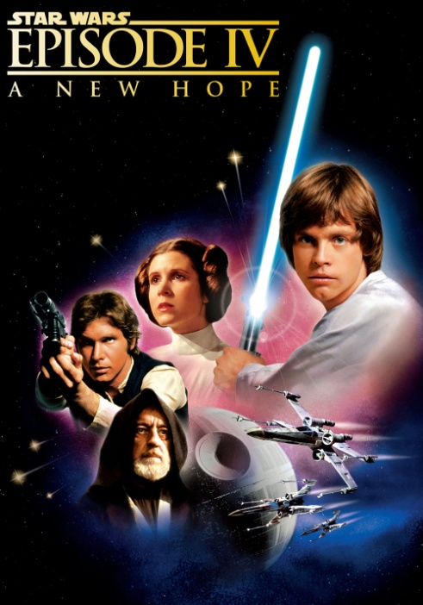

I hope to be able to keep to the same sort of scheme for both my comic and the website. Below is a still from the scene I intend to use. It very much follows the theme of the poster having a dark background while the main focus and brightest colours on the glowing weapons and the on-going battle.

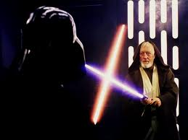

Colour Scheme & Fonts

The film series is set in space so colour schemes can contrast heavily with bright colours representing stars and lights on the backdrop of blackness of space. I intend to use this sort of colour scheme for both the comic strip and the website.

This includes the red and blue lights of the weapons as well as the bold Yellow of the title text. These will be used as base colours and faded gradually into white for a glowing effect.

The black background will also feature white lights to represent distant stars and worlds in this far away galaxy.

Potential Colours:

   

The fonts used in the website need to be bold and easy to read. The fonts in the comic strip can be a little more unorthodox to give it more of a comic strip feel.

Possible fonts to be used in both website and comic strip:

Impact Papyrus Arial Black Kristen ITC Verdana